Operational Research: Tutorial 2 Answers
  - Linear Programming 1
The more complicated questions on the tutorial are marked by:
* Medium
** Hard

Exercises
- Graphically solve the following linear programming (LP) problem
maximise $5x + 17y$
subject to:
$$2x + 3y ≤ 60 \\ x+y≤25 \\ x,y≥0$$
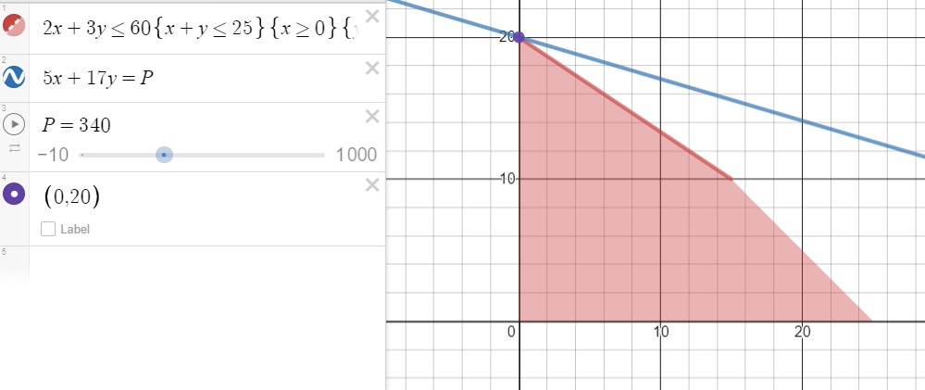
- Express the LP problem in matrix form.

maximise $\left(\begin{matrix}5 & 17\end{matrix}\right)\left(\begin{matrix}x \\ y\end{matrix}\right)$
subject to:
$$\left(\begin{matrix}2 & 3 \\ 1 & 1\end{matrix}\right)≤\left(\begin{matrix}60 \\ 25\end{matrix}\right)$$
and:
$$\left(\begin{matrix}x \\ y\end{matrix}\right)≥\left(\begin{matrix}0 \\ 0\end{matrix}\right)$$

- Implement the problem in Python and use the linprog method to confirm your solution.
Please see the Python code
Note that to maximise a function $f$ you need to minimise $-f$
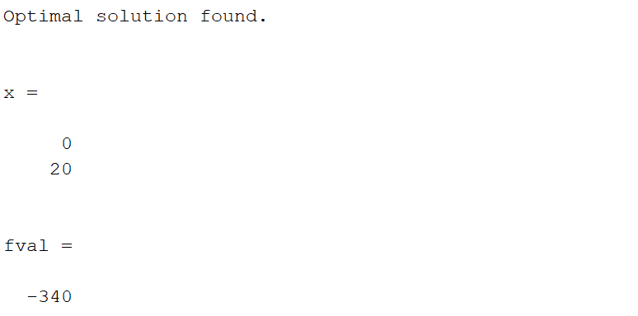
- You should get a similar answer to 3)
- A firm manufactures 2 products, X and Y. *

- Each one is processed by a single machine, machine A, which has a capacity of 100 hours per week.
- It takes 5 hours to make product X and 2 hours to make product Y.
- The profit made (per unit) for X and Y is £12 and £5 respectively.
How many X’s and Y’s should be made per week so that the largest profit is made?

maximise $12x + 5y$
subject to:
$$5x + 2y ≤ 100 \\ x,y≥0$$
Please see the MATLAB code, you should get the following output for the answer.

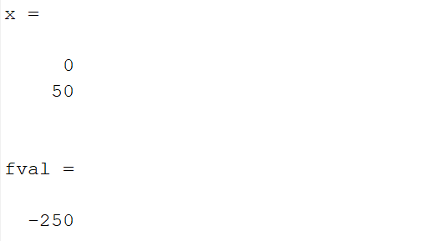

Investigate the following
- The firm adds a third product Z which takes 3 hours to manufacture and has a profit of £8
The firm only has enough material a week to make 20 of product Z
maximise $12x + 5y+8z$
subject to:
$$5x + 2y+3z≤ 100$$
$$z≤20 \\ x,y,z≥0$$
Please see the Python code, you should get the following output for the answer.
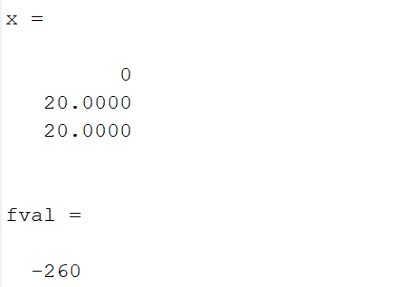
- The firm reduces the time to produce product X to 4.5 hours
What do you notice about the solution, why might this be a non-optimal solution?

Please see the Python code, you should get the following output for the answer.

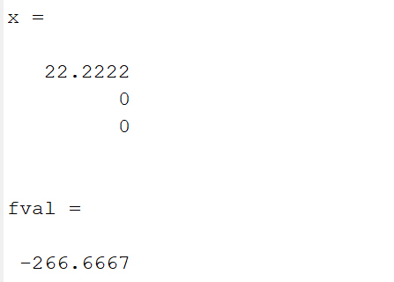
If you can only produce whole numbers, then $x=22$, results in $99$ machine hours, no time to make anything else and a profit of £264.
However, $\left(\begin{matrix}x \\ y \\ z\end{matrix}\right)=\left(\begin{matrix}21 \\ 1 \\ 1\end{matrix}\right)$, results in a machine time of 99.5 hours and a profit of £265. Whilst this might seem negligible, scale these numbers to the thousands or millions!!
- N&F (Management Consultants) have been employed to help the County dieticians develop attractive, nutritious, and economical diets for the county meals service. They have been employed in response to the many complaints about the palatability of the meals provided by this service in recent times. **

The meals provided must satisfy certain basic restriction on vitamin and fat content. Table 1 gives the target quantities for a sample of 4 vitamins and one fat type.

The quantities of each nutrient contained in one unit of each of 10 foods and the cost and attractiveness of a unit of each food is given in table 2.

You are required to:
  - Obtain the optimal solution given that the aim is to minimise the cost of the diet.
  - Obtain the optimal solution given that the aim is to maximise the attractiveness of the diet.
  - Investigate the effects on these solutions if there are maximum and minimum restrictions on both fat and vitamin content where maximum content = minimum content + 20%.

 | Minimum | Maximum
Vitamin A | 100 | -
Vitamin B | 120 | -
Vitamin C | 200 | -
Vitamin D | 80 | -
Fat | - | 300
Table 1

Food | Vitamin A | Vitamin B | Vitamin C | Vitamin D | Fat | Cost | Attractiveness
1 | 18 | 4 | - | 6 | - | 10 | 6
2 | 8 | 6 | 22 | 14 | - | 6 | 1
3 | 22 | 10 | - | - | 8 | 8 | 5
4 | 6 | 12 | - | 6 | - | 16 | 5
5 | - | 14 | - | 10 | - | 8 | 6
6 | - | - | 20 | 8 | 6 | 3 | 4
7 | 8 | - | - | 6 | 20 | 6 | 10
8 | 4 | - | 8 | - | 40 | 8 | 10
9 | - | 6 | 10 | 12 | - | 12 | 6
10 | 12 | 20 | - | 4 | - | 12 | 7
Table 2

Variable $x_{i}$ – Food item $i$
Constants $c_{i}$ – cost of item i
${\left(Va\right)}_{i}$ - Vitamin A content for item i
${\left(Vb\right)}_{i}$ - Vitamin B content for item i
${\left(Vc\right)}_{i}$ - Vitamin C content for item i
${\left(Vd\right)}_{i}$ - Vitamin D content for item i
$F_{i}$ - Fat content for item i

minimise $\sum_{i=1}^{10}{c_{i}x_{i}}$
subject to:
$$\sum_{i=1}^{10}{{(Va)}_{i}x_{i}}≥100$$
$$\sum_{i=1}^{10}{{(Vb)}_{i}x_{i}}≥120$$
$$\sum_{i=1}^{10}{{(Vc)}_{i}x_{i}}≥200$$
$$\sum_{i=1}^{10}{{(Vd)}_{i}x_{i}}≥80$$
$$\sum_{i=1}^{10}{F_{i}x_{i}}≤300$$
$$x_{i}≥0, ∀i$$
Please see the Python code, you should get the following output for the answer.
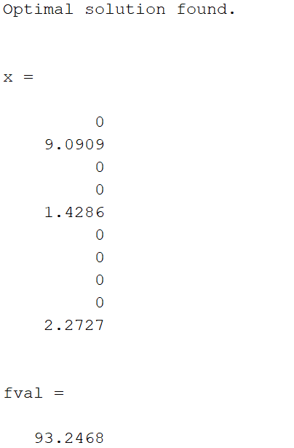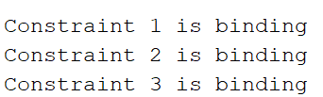

b)
$a_{i}$ – attractiveness of item i
Replace the objective with
maximise $\sum_{i=1}^{10}{a_{i}x_{i}}$
Problem is unbounded, we can pick items with no fat content!!
Please see the Python code, you should an output telling you that the problem is unbounded.

c)
Introduce extra constraints.
$$\sum_{i=1}^{10}{{(Va)}_{i}x_{i}}≤\left(1.2\right)*100$$
$$\sum_{i=1}^{10}{{(Vb)}_{i}x_{i}}≤\left(1.2\right)*120$$
$$\sum_{i=1}^{10}{{(Vc)}_{i}x_{i}}≤\left(1.2\right)*200$$
$$\sum_{i=1}^{10}{{(Vd)}_{i}x_{i}}≤\left(1.2\right)*80$$
$$\sum_{i=1}^{10}{F_{i}x_{i}}≥\frac{300}{1.2}$$
Please see the Python code, you should get the following output for the answer.

